SIMATS ENGINEERING
SAVEETHA INSTITUTE OF MEDICAL AND TECHNICAL SCIENCES
CHENNAI – 602105
Department of Computer Science and Engineering

ASSESSMENT TOOL 3 – INDUSTRY PROBLEM SOLVING

Course Code: | DSA0502 | Course Title: | Query Processing for Data Science
CO Assessed: | CO5 | Assessment: | Tool 3– INDUSTRY PROBLEM SOLVING
Weightage: | 35% | Total Marks:
CO5 Statement: Create meaningful visualizations using Pandas and Matplotlib, including charts, distributions, relationships, and interactive visual representations for effective communication
Student Name: | T NITHIN KUMAR | Reg. No.: | 192424351
Section / Batch: | AI&DS | Date of Submission:
Faculty In-charge: | Dr. B.Shyamala Gowri | Project Mode: | Individual Submission

Code of Conduct
I T NITHIN KUMAR(192424351)(Name / Reg No) certify that this submission is my original work and that I have adhered to all guidelines specified for this assessment. I understand that any violation of academic integrity rules will result in disciplinary action.
Signature: _________________________

Activity 1: Basic Plot Creation

1. Aim
To create a small monthly sales dataset and visualize it using a Matplotlib line plot, including a title, axis labels, legend, grid, markers, and data-value annotations on each point.

2. Python Code

# Activity 1: Basic Plot Creation - Monthly Sales Line Plot

# Step 1: Import required libraries
import matplotlib.pyplot as plt

# Step 2: Store the data using Python lists
months = ["January", "February", "March", "April", "May", "June"]
sales = [120, 150, 180, 160, 210, 250]

# Step 3: Create a line plot
plt.figure(figsize=(8, 5))
plt.plot(months, sales, marker="o", color="blue", linewidth=2, label="Monthly Sales")

# Step 4: Add title, axis labels, legend, and grid
plt.title("Monthly Sales")
plt.xlabel("Month")
plt.ylabel("Sales")
plt.legend()
plt.grid(True, linestyle="--", alpha=0.6)

# Step 5: Add data-value annotations on each point
for i in range(len(months)):
plt.annotate(str(sales[i]), (months[i], sales[i]),
textcoords="offset points", xytext=(0, 10),
ha="center", fontsize=9, color="darkblue")

# Step 6: Display the plot
plt.tight_layout()
plt.show()

3. Code Explanation
Code Part | Explanation
Import library | matplotlib.pyplot is imported as plt — this is the standard module used for creating charts and graphs in Python.
Store the data | The months and their corresponding sales figures are stored in two simple Python lists, months and sales, keeping the two lists in the same order so each month lines up with its sales value.
Create the line plot | plt.plot() draws a line connecting the six data points. marker="o" places a circular marker on every data point, and linewidth=2 makes the line clearly visible.
Add title and axis labels | plt.title(), plt.xlabel(), and plt.ylabel() label the chart as "Monthly Sales", with "Month" on the x-axis and "Sales" on the y-axis.
Add legend and grid | plt.legend() displays the label given to the line ("Monthly Sales"), and plt.grid() adds light dashed gridlines to make the chart easier to read.
Annotate data values | A for loop goes through every month, using plt.annotate() to print the exact sales number just above each marker, so the viewer can read exact values without guessing from the axis.
Display the plot | plt.show() renders the completed chart on the screen.
4. Expected Output
Running the code produces a single line chart titled "Monthly Sales", with the six months (January to June) on the x-axis and sales values on the y-axis. The line rises and falls following the sales trend — increasing steadily except for a small dip in April — with a circular marker at each month and the exact sales number (120, 150, 180, 160, 210, 250) printed just above each marker. A legend box labeled "Monthly Sales" appears in the upper-left corner, and light dashed gridlines run across the chart.
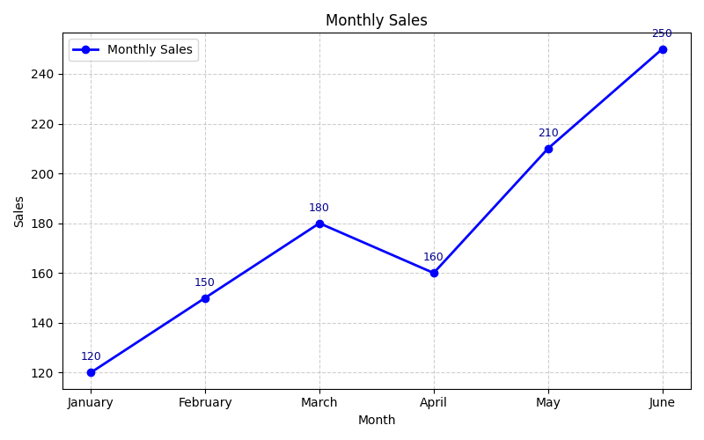
Figure 1: Output of Activity 1 — Monthly Sales Line Plot with data-value annotations

Activity 2: Compare Visualization Types

1. Aim
To use the exact same monthly sales dataset from Activity 1 to create three different types of visualizations — a line plot, a bar plot, and a scatter plot — and to compare their effectiveness for showing monthly sales trends.

2. Python Code

# Activity 2: Compare Visualization Types - Line, Bar, and Scatter Plots

# Step 1: Import required libraries
import matplotlib.pyplot as plt

# Step 2: Use the same monthly sales dataset as Activity 1
months = ["January", "February", "March", "April", "May", "June"]
sales = [120, 150, 180, 160, 210, 250]

# ---------------------------------------------------
# Plot 1: Line Plot
# ---------------------------------------------------
plt.figure(figsize=(8, 5))
plt.plot(months, sales, marker="o", color="blue", linewidth=2, label="Monthly Sales")
plt.title("Monthly Sales - Line Plot")
plt.xlabel("Month")
plt.ylabel("Sales")
plt.legend()
plt.grid(True, linestyle="--", alpha=0.6)
plt.tight_layout()
plt.show()

# ---------------------------------------------------
# Plot 2: Bar Plot
# ---------------------------------------------------
plt.figure(figsize=(8, 5))
plt.bar(months, sales, color="seagreen", edgecolor="black", label="Monthly Sales")
plt.title("Monthly Sales - Bar Plot")
plt.xlabel("Month")
plt.ylabel("Sales")
plt.legend()
plt.grid(True, axis="y", linestyle="--", alpha=0.6)
plt.tight_layout()
plt.show()

# ---------------------------------------------------
# Plot 3: Scatter Plot
# ---------------------------------------------------
plt.figure(figsize=(8, 5))
plt.scatter(months, sales, color="crimson", marker="o", s=100,
edgecolor="black", label="Monthly Sales")
plt.title("Monthly Sales - Scatter Plot")
plt.xlabel("Month")
plt.ylabel("Sales")
plt.legend()
plt.grid(True, linestyle="--", alpha=0.6)
plt.tight_layout()
plt.show()

3. Code Explanation
Code Part | Explanation
Same dataset reused | The exact same months and sales lists from Activity 1 are reused here, so all three charts are drawn from identical data — this keeps the comparison fair.
Line Plot | plt.plot() with marker="o" draws sales as a connected line, which is best for showing how a value changes step by step over time.
Bar Plot | plt.bar() draws one vertical bar per month with its height equal to the sales value, which is best for comparing sales between individual months side by side.
Scatter Plot | plt.scatter() draws an individual point/marker for each month's sales value without connecting them with a line, which is best for viewing individual data points without implying a trend between them.
Titles, labels, legend, grid | Each of the three plt.figure() blocks sets its own title (e.g., "Monthly Sales - Bar Plot"), x/y-axis labels, a legend, and gridlines, keeping every chart clearly labeled and easy to read on its own.
Displaying all three charts | Each chart is created in its own plt.figure() block followed by its own plt.show(), so the three visualizations are displayed one after another as separate figures.
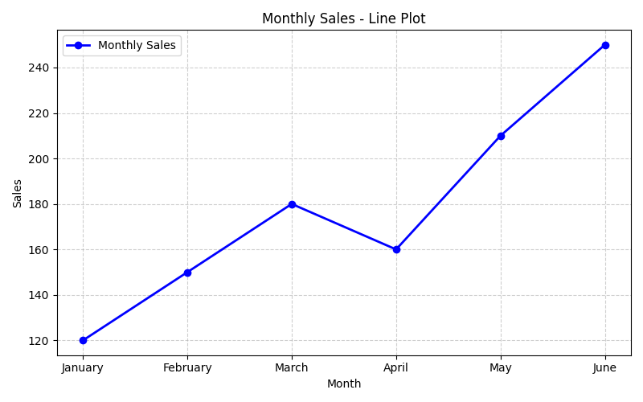
Figure 2: Line Plot — shows the sales trend across months
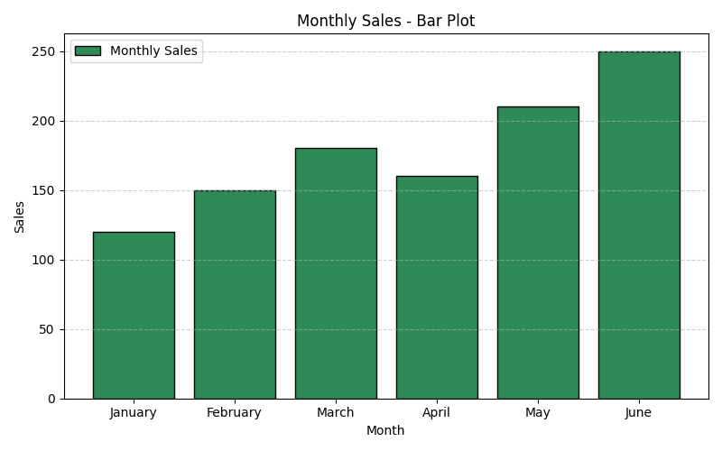
Figure 3: Bar Plot — compares sales values between individual months
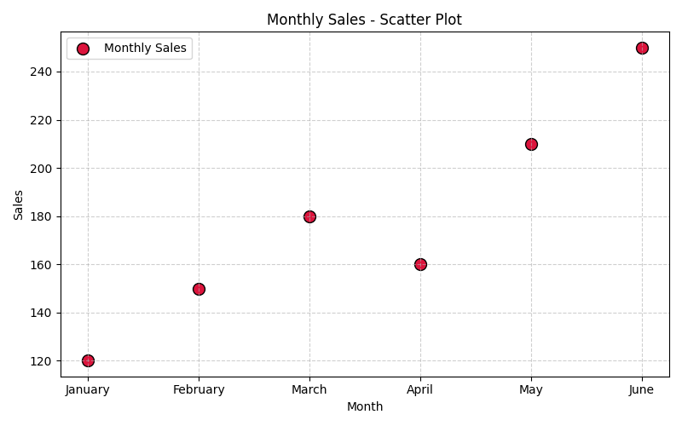
Figure 4: Scatter Plot — shows each month's sales as an individual point
4. Comparison of Line, Bar, and Scatter Plots
Plot Type | How it Displays Data | Purpose / Advantage | Effect on Monthly Sales Data
Line Plot | Connects data points with a continuous line, following their order. | Best for showing trends, growth, or decline over a continuous sequence such as time. | Clearly shows the overall upward/downward direction of sales month by month; easy to spot rises and dips.
Bar Plot | Draws a separate bar for each category, with height representing the value. | Best for comparing distinct categories or discrete values against each other. | Makes it very easy to compare the exact sales of one month directly against another month at a glance.
Scatter Plot | Plots each data point individually without connecting lines. | Best for showing individual values, distribution, or relationships between two variables, especially when there is no continuous connection to imply. | Shows each month's sales as a standalone value, useful for spotting individual highs/lows but does not visually indicate the trend direction as clearly as a line plot.

